What is Good
Act justly, love mercy, walk humbly

This is the year I apply for Medicare. It's the year I can choose to stop working. It also feels like the year I am officially old, and I feel it. I don’t feel as strong as I used to, I’m tired a little earlier in the day, and I forget things. I don’t sleep as well as I used to. As our strength wanes and our hair turns gray, my husband and I talk about the life God wants us to live now.

He has shown you, O mortal, what is good. And what does the Lord require of you? To act justly and love mercy and to walk humbly with your God. Micah 6:8

God has shown me what is good. He has shown me what he wants from me. I have a blueprint for the impact God wants me to make.

Act justly: Treat others with firmness, honesty, and humility. Do what is morally right, even when it is difficult. Stand up for the vulnerable and oppressed.

See people as God sees them.

Love mercy. Extend forgiveness to those within my reach. Rebuke vengeance. Do not rejoice when a foe is punished. Actively extend kindness, compassion, and forgiveness to others, even when they have wronged me and especially when they are hurting. Have empathy and seek the best for others

Maintain a posture of Grace.

Walk humbly: Keep a modest self-view. Recognize my own dependence on God for everything. Serve others. Have a willingness to submit myself to God’s will for my life, even when it's hard.

Depend on God for everything.

Micah 6:8 is a goal for me. I want my community to see more than a church lady, an activist, a Christian, or a missionary. I want my community to see Brenda, who does what is good.

God is after our heart motives, not our outward religious activity. In a world that is saturated with injustice, hatred, and arrogance, let's be people who do what is good.

Brenda Boston

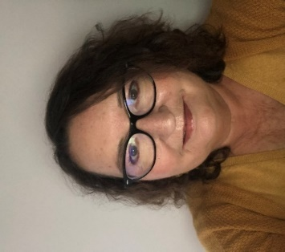

Brenda would like people to think of her as someone who loves Jesus and tries to do what is right according to His teachings. Imperfect, but always striving. She has been a missionary, pastor's wife, RN, friend, sister, daughter, mother, and grandmother. Each role brings its own challenges and blessings. She is thankful for the ministry of Daughters of Zion and grateful to be accepted into the group, which she is blessed to attend as often as her busy life allows.

